North Newton Jr/Sr High School
Welcome Back!

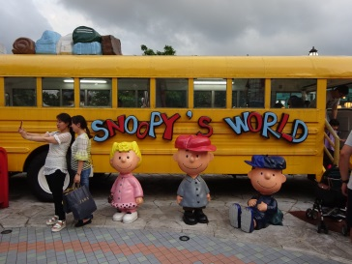

Menu subject to change
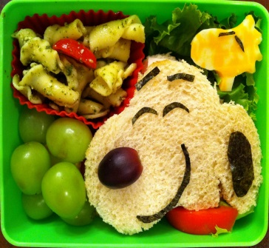
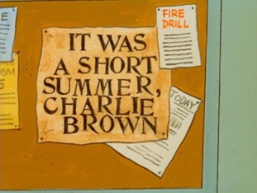

TEACHER
DAY

TEACHER
DAY
STUDENT FIRST FULL DAY
Pizza
Green Beans
Fruit
Milk
BBQ Pulled Pork
WG Bun
French Fries
Fruit
Milk
Philly Steak/Sub Bun
Peppers
Corn
Fruit
Milk
Fajita Wrap
Meat, Cheese, Shell
Lettuce, Refried Beans
Peas
Fruit
Milk
Meatball Sub
Meatballs, Sauce
Mozzarella Cheese
Sub Bun
Broccoli
Fruit
Milk
Grill Chicken Wrap
Chicken, Soft Shell
Cheese, Lettuce
Red Sidekick
Fruit
Milk

Breakfast for Lunch
Glazed French Toast
Syrup
Ham, Potato
100% Juice
Milk
Corndog
Baked Beans
Mixed Vegetables
Fruit
Milk
Beef Taco
Meat, Cheese, Salsa
Lettuce, Soft shell
Corn
Fruit
Milk
Chicken & Noodles
Hot Roll
Mashed Potatoes
Carrots
Fruit
Milk
Breaded Chicken Patty
WG Bun
Green Beans
Fresh Apple Slices
Milk
This Institution is an Equal Opportunity Provider
Chicken Nuggets
Dipping Sauce
Hot Roll
Mixed Vegetables
Fruit
Milk
Chicken Parmesan
Chicken, Sauce, Cheese
On top of Spaghetti
Garlic Bread
Peas
Fruit
Milk

