Elementary K-6th Grade
Welcome Back

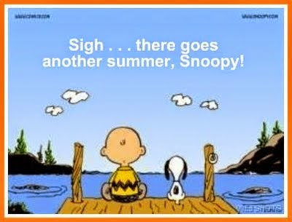

Menu subject to change
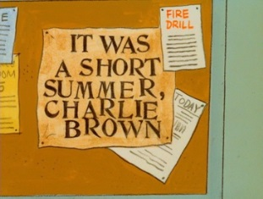

TEACHER
DAY

TEACHER
DAY
STUDENT FIRST FULL DAY
Pizza
Green Beans
Fruit
Milk
BBQ Pulled Pork
WG Bun
Fries
Fruit
Milk
Hotdog/WG Bun
Baked Beans
Mixed Vegetables
Fruit
Milk
Fajita Wrap
Meat, Cheese, Shell
Lettuce, Salsa
Peas
Fruit
Milk
Ham & Cheese
WG Bun
Broccoli
Fresh Apple Slices
Milk

Grill Chicken Wrap
Chicken, Soft Shell
Cheese, Lettuce
Cherry Sidekick
Fruit
Milk
Breakfast for Lunch
Glazed French Toast
Syrup
Ham, Potato
100% Juice
Milk
Breaded Chicken
Patty/WG Bun
Green Beans
Fruit
Milk
Beef Taco
Meat, Cheese, Salsa
Lettuce, Soft Shell
Corn
Fruit
Milk
Chicken & Noodles
Mashed Potatoes
Hot Roll
Fruit
Milk
Corndog
Baked Beans
Carrots
Fruit
Milk
This Institution is an Equal Opportunity Provider
Hamburger/WG Bun
Cheese Slice
Pickles
Corn
Fruit
Milk
Chicken Parmesan
Chicken, Sauce Cheese
On top of Spaghetti
Garlic Bread
Peas
Fruit
Milk

