Elementary K -6th Grade
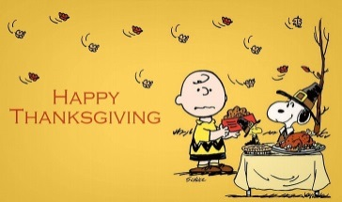

Menu subject to change
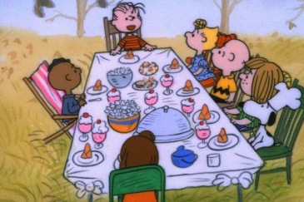
Calzone
Carrots
Fruit
Milk
Pulled Pork/WG Bun
Potato
Fruit
Milk
Hotdog/WG Bun
Baked Beans
Dragon Punch
Fruit
Milk

COOK’S
CHOICE
Pizza
Broccoli
Fruit
Milk
Chicken Tenders
Green Beans
Bread
Fruit
Milk
Hamburger, Cheese Slice
WG Bun
Potato
Fruit
Milk
Taco
Meat, Cheese, Lettuce
Salsa, Shell
Refried Beans
Red Sidekick
Fruit
Milk
Sub Sandwich
Deli Turkey, Ham, Cheese
On Sub Bun
Lettuce, Fresh Veggies
Fruit
Milk

COOK’S
CHOICE
Diced Chicken BBQ
WG Bun
Potato
Fruit
Milk
Nachos
Meat, Cheese, Chips
Salsa, Corn
Fruit
Milk
Grilled Chicken Salad
Meat, Cheese, Lettuce
Dressing, Bread
Dragon Punch
Fruit
Milk
Turkey & Noodles
Mashed Potatoes
Hot Roll
Fruit
Milk
Mini Corndogs
Baked Beans
Broccoli
Fruit
Milk

COOK’S
CHOICE
Pizza
Green Beans
Fruit
Milk

Thanksgiving
Break
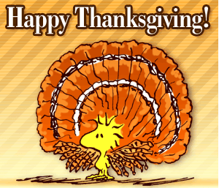

No
School
This institution is an equal opportunity provider
BBQ Grilled Chicken Patty
WG Bun
Corn
Fruit
Milk
Hamburger Gravy
Mashed Potatoes
Carrots
Bread
Fruit
Milk

