North Newton Jr/Sr High School
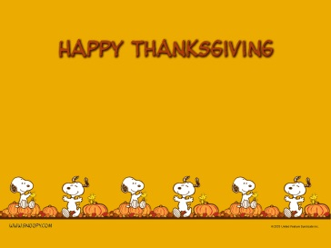

Menu subject to change 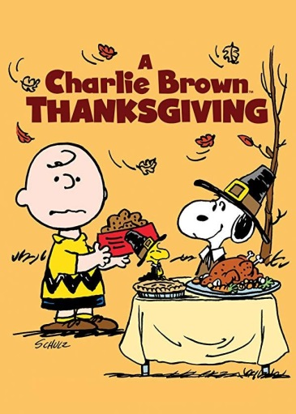
Calzone
Carrots
Fruit
Milk
BBQ Pulled Pork/WG Bun
Potato
Fruit
Milk

COOK’S
CHOICE
Turkey & Noodles
Mashed Potatoes
Hot Roll
Fresh Apple Slices
Milk
Mini Corn Dogs
Baked Beans
Broccoli
Fruit
Milk
Breakfast for Lunch
Pancakes
Egg, Potato
100% Juice
Milk
Hamburger/WG Bun
Cheese Slice
Potato
Furit
Milk
Taco Salad
Meat, Cheese, Lettuce
Salsa, Bread Stick
Refried Beans
Fruit
Milk
Spaghetti in Meat Sauce
Garlic Bread
Lettuce Salad
Fruit
Milk
Ham & Cheese
WG Bun
Potato
Fruit
Milk
Diced Chicken BBQ
WG Bun
Potato
Fruit
Milk
Nachos
Meat, Cheese, Chips
Salsa, Corn
Fruit
Milk
Grilled Chicken Salad
Meat, Cheese, Lettuce
Bread
Dragon Punch
Fresh Veggies
Milk
Turkey & Gravy
Mashed Potatoes
Hot Roll
Fruit
Milk

Hotdog/WG Bun
Baked Beans
Broccoli
Fruit
Milk

COOK’S
CHOICE
Pizza
Green Beans
Fruit
Milk

Thanksgiving
Break

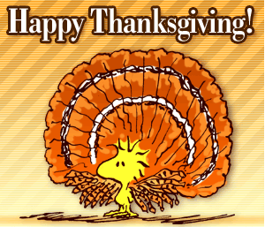

No
School
This Institution is an equal opportunity provider
BBQ Chicken Patty
WG Bun
Mixed Vegetables
Fruit
Milk
Hamburger Gravy
Mashed Potatoes
Carrots
Hot Roll
Fruit
Milk

