Elementary K-6th Grade
Have a great summer!!
See you in August!!

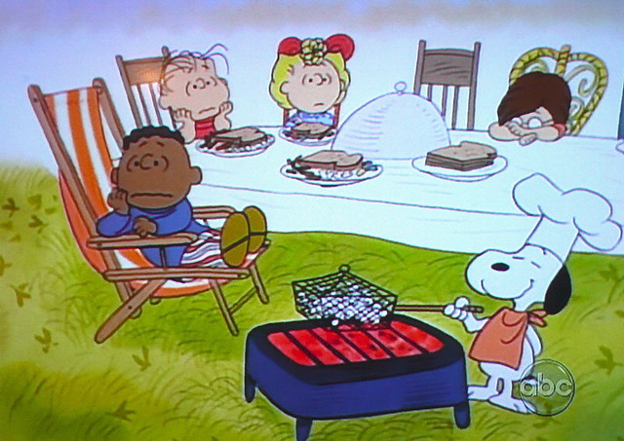

Menu subject to change

COOK’S
CHOICE
Pasta with Meat Sauce
Bread Stick
Green Beans
Fruit
Milk
Pulled Pork
WG Bun
Cheese Potatoes
Fresh Apple Slices/Dip
Milk
Nachos
Meat, Cheese, Chips
Refried Beans, Salsa
Dragon Punch
Fruit
Milk
Chicken Nuggets
Hot Roll
Broccoli
Fruit
Milk
Breakfast for Lunch
French Toast/Syrup
Egg Patty
Potato
100% Juice
Milk
Sloppy Joe
WG Bun
Corn
Baked Beans
Fruit
Milk
Chicken Wrap
Meat, Cheese, Shell
Lettuce, Salsa
Sweet Potato Fries
Fruit
Milk
Turkey Manhattan
Turkey Slice, WG Bread
Mashed Potatoes/Gravy
Fruit
Milk
Pizza
Lettuce Salad
Cinnamon Apples
Milk
Hot Ham & Cheese
WG Bun
Baked Beans
Potato
Fruit
Milk
Chicken Tenders
Bread Stick
Broccoli
Fruit
Milk
Soft Shell Taco
Meat, Cheese, Shell
Salsa, Lettuce
100% Juice
Fresh Apple Slices/Dip
Milk

Turkey & Noodles
Mashed Potatoes
Hot Roll
Fruit
Milk

COOK’S
CHOICE
Fajita
Meat, Cheese, Shell
Corn
Fruit
Milk
Sub Sandwich
Meat, Cheese
WG Sub Bun
Potato
Fruit
Milk
Chicken & Noodles
Mashed Potatoes
Hot Roll
Fruit
Milk
LAST STUDENT DAY

COOK’S
CHOICE
THIS INSTITUTION IS AN EQUAL OPPORTUNITY PROVIDER

